**Objective:**

To design a microcontroller circuit using LM016L LCD.

**Instrument:**

1. PIC16F873 (1)
2. LM016L LCD (1)
3. Button(s) (2)

**Source code:**

sbit LCD_RS at RB4_bit;

sbit LCD_EN at RB5_bit;

sbit LCD_D4 at RB0_bit;

sbit LCD_D5 at RB1_bit;

sbit LCD_D6 at RB2_bit;

sbit LCD_D7 at RB3_bit;

sbit LCD_RS_Direction at TRISB4_bit;

sbit LCD_EN_Direction at TRISB5_bit;

sbit LCD_D4_Direction at TRISB0_bit;

sbit LCD_D5_Direction at TRISB1_bit;

sbit LCD_D6_Direction at TRISB2_bit;

sbit LCD_D7_Direction at TRISB3_bit;

void main()

{

trisb=0b00000000;

portb =0b00000000;

trisc=0b00000011;

portc =0b00000000;

Lcd_Init();

Lcd_Cmd(_LCD_CURSOR_OFF);

Lcd_out(1,1, " P U C");

while(1)

{

if(portc==0b00000001)

{

Lcd_Cmd(_LCD_CLEAR);

Lcd_out(1,1,"Name: Sathi");

Lcd_out(2,1," ID : 383");

}

if(portc==0b00000010)

{

Lcd_Cmd(_LCD_CLEAR);

Lcd_out(1,1," ID : 383");

Lcd_out(2,1,"Name: Sathi");

}

}

}

**Circuit diagram:** 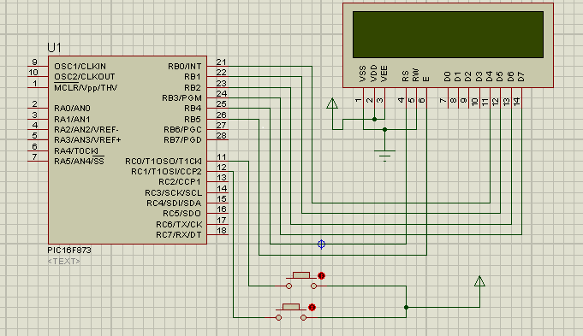

**Schematic diagram:**

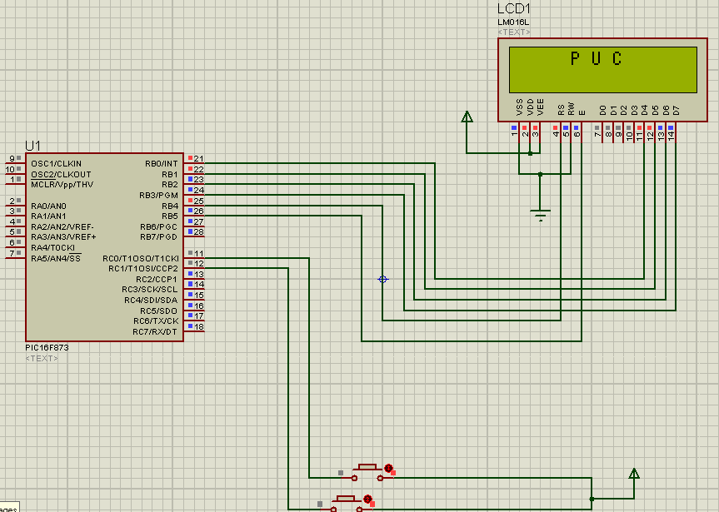

**Conclusion:**

In this experiment we have used a microcontroller named PIC16F873, two buttons and a LCD (LM016L) for design. Finally we have shown some text as like name of university, students name & ID etc. in the above LCD which is done by respective use of button 1 & 2.